数据字典SEMASTER.SYS_TABLEINFO中添加一行：
TCODE | TNAME | TTYPE | TOWNER
TB4064_PASCHEDULE | 广播时间表 | 0 | 0

数据字典中SEMASTER.SYS_FIELDINFO添加一行：
列名 | FIDX | FCODE | FNAME | TCODE | FTYPE | FLENGTH
列值 | 0 | F4064_SCHEDULENO | 时间表编号 | TB4064_PASCHEDULE |  | 0
 | 0 | F4064_SCHEDULETYPE | 时间表类型 | TB4064_PASCHEDULE |  | 0
 | 0 | F4064_VALID | 是否有效 | TB4064_PASCHEDULE |  | 0
 | 0 | F4064_START | 开始时刻 | TB4064_PASCHEDULE |  | 0
 | 0 | F4064_END | 停止时刻 | TB4064_PASCHEDULE |  | 0
 | 0 | F4064_INTERVAL | 发送间隔 | TB4064_PASCHEDULE |  | 0
 | 0 | F4064_WEEK | 激活日 | TB4064_PASCHEDULE |  | 0
 | 0 | F4064_VALIDDATE | 生效日期 | TB4064_PASCHEDULE |  | 0
 | 0 | F4064_TYPE | 广播类型 | TB4064_PASCHEDULE |  | 0
 | 0 | F4064_VOICENO | 语音编号 | TB4064_PASCHEDULE |  | 0
 | 0 | F4064_BAYAREA | 广播区域 | TB4064_PASCHEDULE |  | 0
 | 0 | F4064_PARA | 控制参数 | TB4064_PASCHEDULE |  | 0

FPREC | SHOW | FTYPEDESC
0 | 0
0 | 0
0 | 0
0 | 0
0 | 0
0 | 0
0 | 0
0 | 0
0 | 0
0 | 0
0 | 0
0 | 0
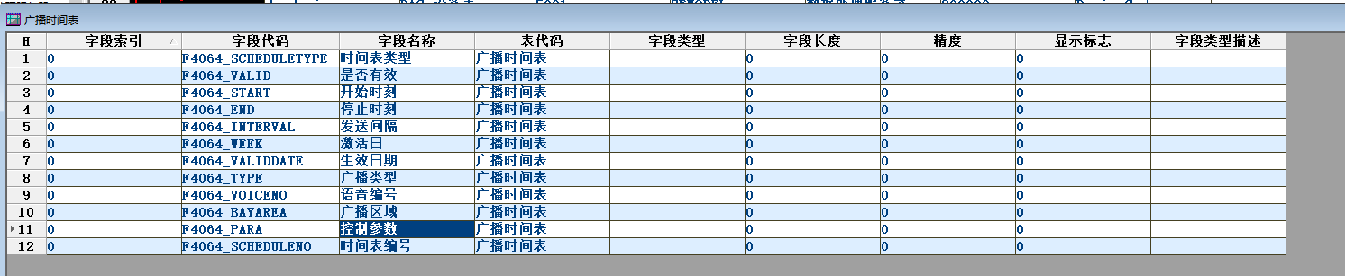

实时库表信息字典TB0010_RDBTABINFO新增行
sql文件rdbTbl.sql
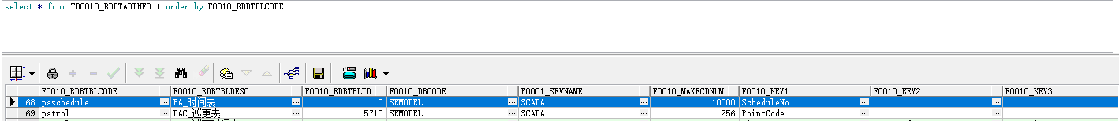
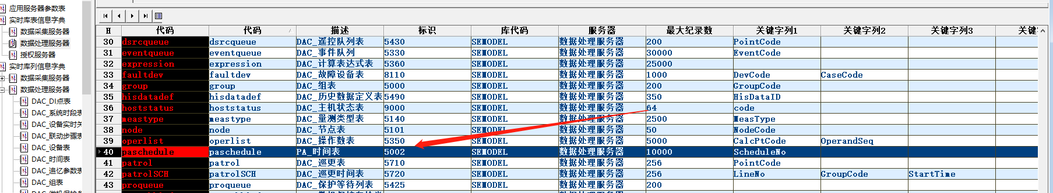
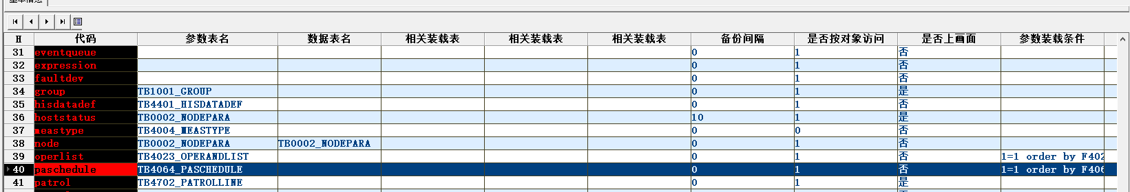
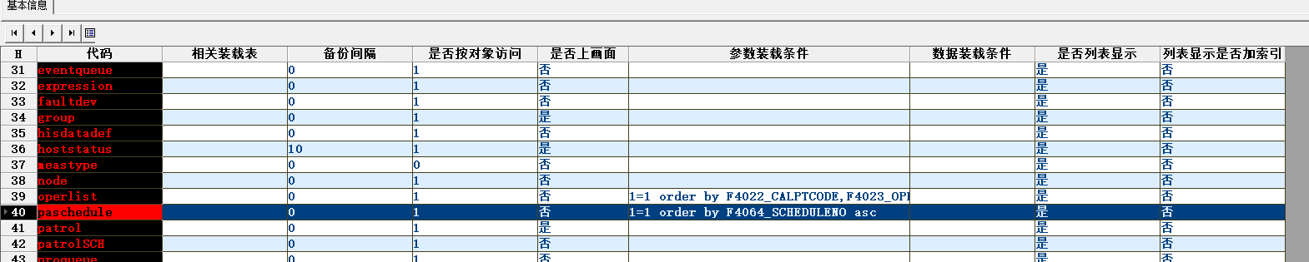

实时库列信息字典TB0011_RDBCOLINFO新增13行：
sql文件rdbCol.sql
列名 | F0011_RDBCOLCODE | F0011_RDBCOLDESC | F0010_RDBTBLCODE | F0011_DATLEN | F0011_DATTYPE
列值

F0011_BITNUM | F0011_COLTYPE | F0011_SERIALNO | F0011_DISPF | F0011_DATADISPF

F0011_DEFAULTINT | F0011_DEFAULTFLOAT | F0011_DEFAULTSTRING
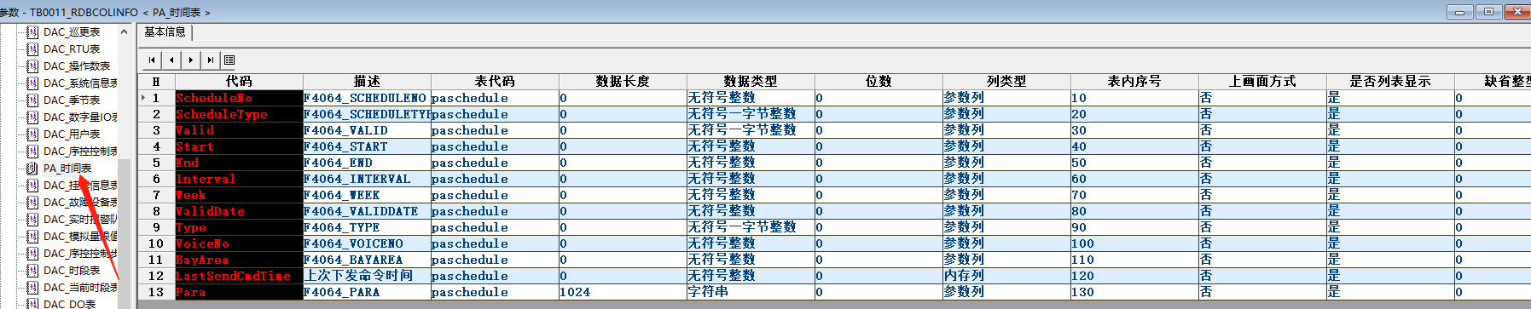
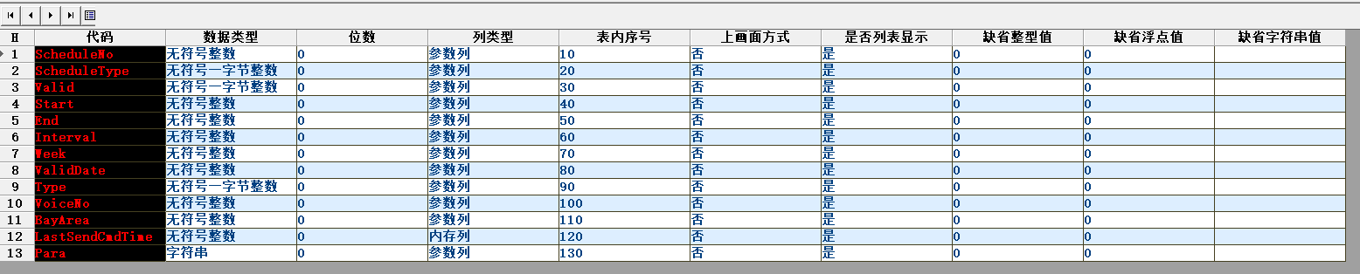

参数置库表规则TB0021_TABLES增加一行
sql文件21tabs.sql
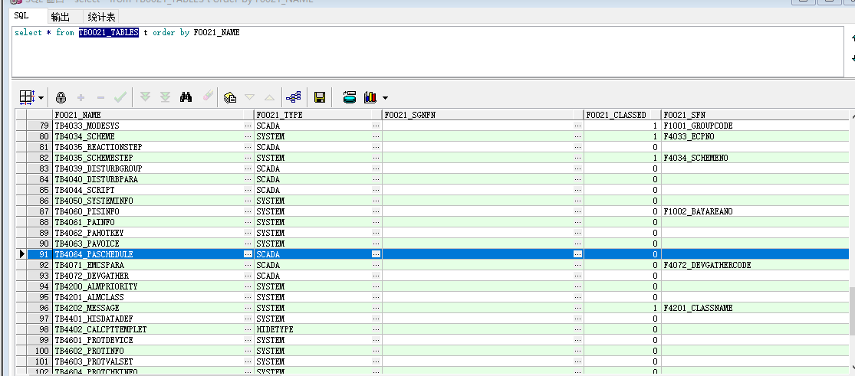
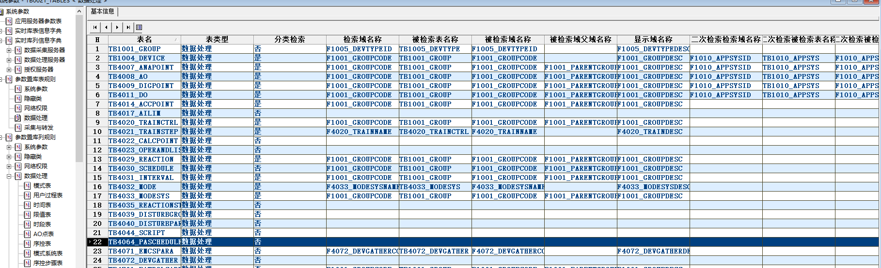
参数置库列规则TB0022_FIELDS增加12行
sql文件22col.sql
