一．所有表都在SEMODEL里。
二．新增数据库表
1. 教案目录表 ： TB7000_LESSONCATALOG
F7000_ID INT NOT NULL,
F7000_NAME VARCHAR(64) NOT NULL,
F7000_PARENTID INT NOT NULL,
PRIMARY KEY (F7000_ID)
2. 试卷目录表 ： TB7006_EXAMCATALOG
F7006_ID INT NOT NULL,
F7006_NAME VARCHAR(64) NOT NULL,
F7006_PARENTID INT NOT NULL,
PRIMARY KEY (F7006_ID)
3. 试卷表 ： TB7007_EXAMINFO
F7007_EXAMNAME VARCHAR(256) NOT NULL,
F7007_EXAMDATE INT NOT NULL,
F7007_EXAMLIMIT INT NOT NULL,
F7007_MAKER VARCHAR(24) NULL,
F7006_ID INT NOT NULL,
PRIMARY KEY (F7007_EXAMNAME)
4. 试卷题目表 ： TB7008_EXAMINATION
F7007_EXAMNAME VARCHAR(256) NOT NULL,
F7008_QUESTIONNO INT NOT NULL,
F7001_LESSONNAME VARCHAR(64) NOT NULL,
F7008_VALUE INT NOT NULL,
F7008_REMARK VARCHAR(256) NULL,
PRIMARY KEY (F7007_EXAMNAME,F7008_QUESTIONNO)
5. 试卷答案表 ： TB7009_EXAMSTANDARD
F7007_EXAMNAME VARCHAR(256) NOT NULL,
F7008_QUESTIONNO INT NOT NULL,
F7001_LESSONNAME VARCHAR(64) NOT NULL,
F7009_CHILDLESSON VARCHAR(64) NULL,
F7009_OPERATENO INT NOT NULL,
F7003_OPERATETYPE TINYINT UNSIGNED NOT NULL,
F7002_POINTCODE VARCHAR(64) NOT NULL,
F7002_CTRLVALUE FLOAT NOT NULL,
F7003_GROUPNO INT NOT NULL,
F7009_CHILDGROUP INT NOT,NULL,
PRIMARY KEY (F7007_EXAMNAME,F7008_QUESTIONNO,F7009_OPERATENO)
注意：F7009_CHILDGROUP的默认值为-1。
6. 计划目录表 ： TB7010_PLANCATALOG
F7010_ID INT NOT NULL,
F7010_NAME VARCHAR(64) NOT NULL,
F7010_PARENTID INT NOT NULL,
PRIMARY KEY (F7010_ID)
7. 计划表 ： TB7011_PLANINFO
F7011_PLANNAME VARCHAR(256) NOT NULL,
F7011_PLANDATE INT NOT NULL,
F7011_MAKER VARCHAR(24) NULL,
F7011_STATE INT NOT NULL,
F7010_ID INT NOT NULL,
PRIMARY KEY (F7011_PLANNAME)
8. 计划安排表 ： TB7012_EXAMPLAN
F7011_PLANNAME VARCHAR(256) NOT NULL,
F7012_EXAMINEE VARCHAR(24) NOT NULL,
F7007_EXAMNAME VARCHAR(256) NOT NULL,
F7012_EXAMSCORE INT NOT NULL,
F7007_EXAMLIMIT INT NOT NULL,
PRIMARY KEY (F7011_PLANNAME,F7012_EXAMINEE,F7007_EXAMNAME)
9. 操作记录表 ： TB7013_OPERATINGRECORD
F7011_PLANNAME VARCHAR(256) NOT NULL,
F7012_EXAMINEE VARCHAR(24) NOT NULL,
F7007_EXAMNAME VARCHAR(256) NOT NULL,
F7008_QUESTIONNO INT NOT NULL,
F7013_STARTTIME INT NULL,
F7001_LESSONNAME VARCHAR(64) NOT NULL,
F7009_CHILDLESSON VARCHAR(64) NULL,
F7013_OPERATENO INT NOT NULL,
F7003_OPERATETYPE TINYINT UNSIGNED NOT NULL,
F7002_POINTCODE VARCHAR(64) NOT NULL,
F7002_CTRLVALUE FLOAT NOT NULL,
F7003_GROUPNO INT NOT NULL,
F7009_CHILDGROUP INT NOT NULL,
F7013_STAGE TINYINT UNSIGNED NULL,
F7013_OPERATETIME INT NULL,
F7013_ISERROR INT NULL,
F7013_ENDTIME INT NULL,
PRIMARY KEY (F7011_PLANNAME,F7012_EXAMINEE,F7007_EXAMNAME,F7008_QUESTIONNO,F7013_OPERATENO)
10. 考试结果表 ： TB7014_EXAMRESULT
F7011_PLANNAME VARCHAR(256) NOT NULL,
F7012_EXAMINEE VARCHAR(24) NOT NULL,
F7007_EXAMNAME VARCHAR(256) NOT NULL,
F7014_MACHINESCORE INT NOT NULL,
F7014_TEACHERSCORE INT NOT NULL,
F7014_STARTTIME INT NULL,
F7014_ENDTIME INT NULL,
F7014_EXAMINER VARCHAR(24) NULL,
F7014_REMARK VARCHAR(256) NULL,
PRIMARY KEY (F7011_PLANNAME,F7012_EXAMINEE,F7007_EXAMNAME)
三．更改数据库表
1. 教案表 ： TB7001_DTSLESSON
F7001_LESSONNAME扩大成VARCHAR(64)；
F7001_LESSONDESC扩大成VARCHAR(128)；
增加一列，F7000_ID INT NOT NULL。
2. 教案条件设置表 ： TB7002_DTSCONDITION
F7001_LESSONNAME扩大成VARCHAR(64)；
F7002_POINTCODE扩大成VARCHAR(64)；
3. 教案操作步骤表 ： TB7003_DTSOPERATE
F7001_LESSONNAME扩大成VARCHAR(64)；
F7002_POINTCODE扩大成VARCHAR(64)；
增加一列，F7003_GROUPNO INT NOT NULL。
四．实时库表信息字典的培训服务器增加表
1. 计划安排表
examPlan 计划安排表 7331 SEMODEL DTS 5000 PlanName Examinee ExamName TB7012_EXAMPLAN 0 1 0 1=1 order by F7011_PLANNAME,F7012_EXAMINEE 1 0
2. 考试状态表
examState 考试状态表 7332 SEMODEL DTS 50 PlanName Examinee ExamName QuestionNo 0 0 0 1 0
3. 操作记录表
operatingRecord 操作记录表 7333 SEMODEL DTS 5000 PlanName Examinee ExamName QuestionNo OperateNo 0 0 0 1 0
五．实时库列信息字典
1. 计划安排表
2. 考试状态表

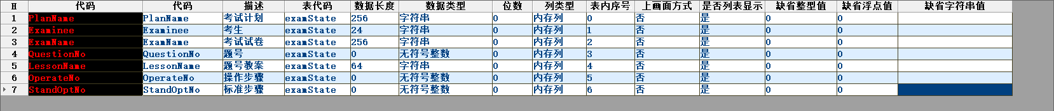
3. 操作记录表
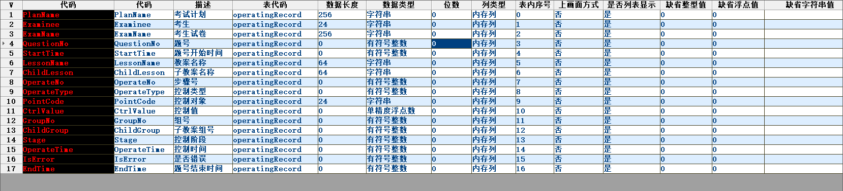
4. DTS参数运行表增加一列
